Object | Estimated Mass | Letter balance reading
1.
2.
3.
4.
5.
6.
7.
8.
9.

10.
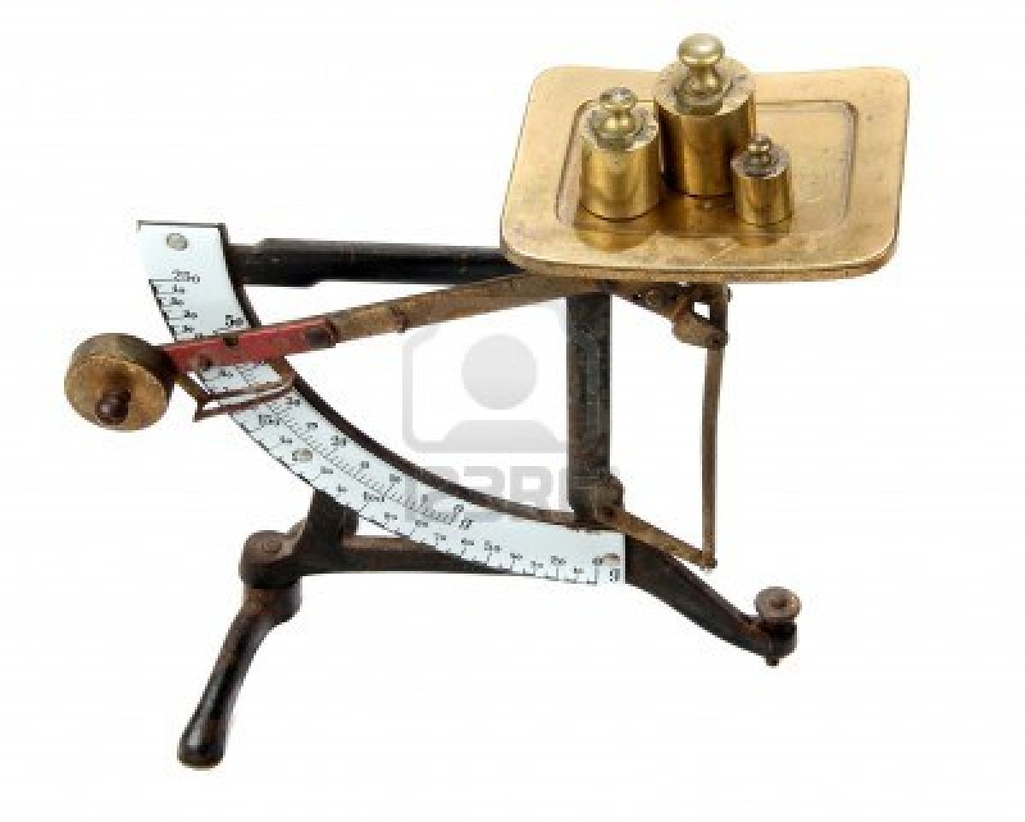
Balance – scale

